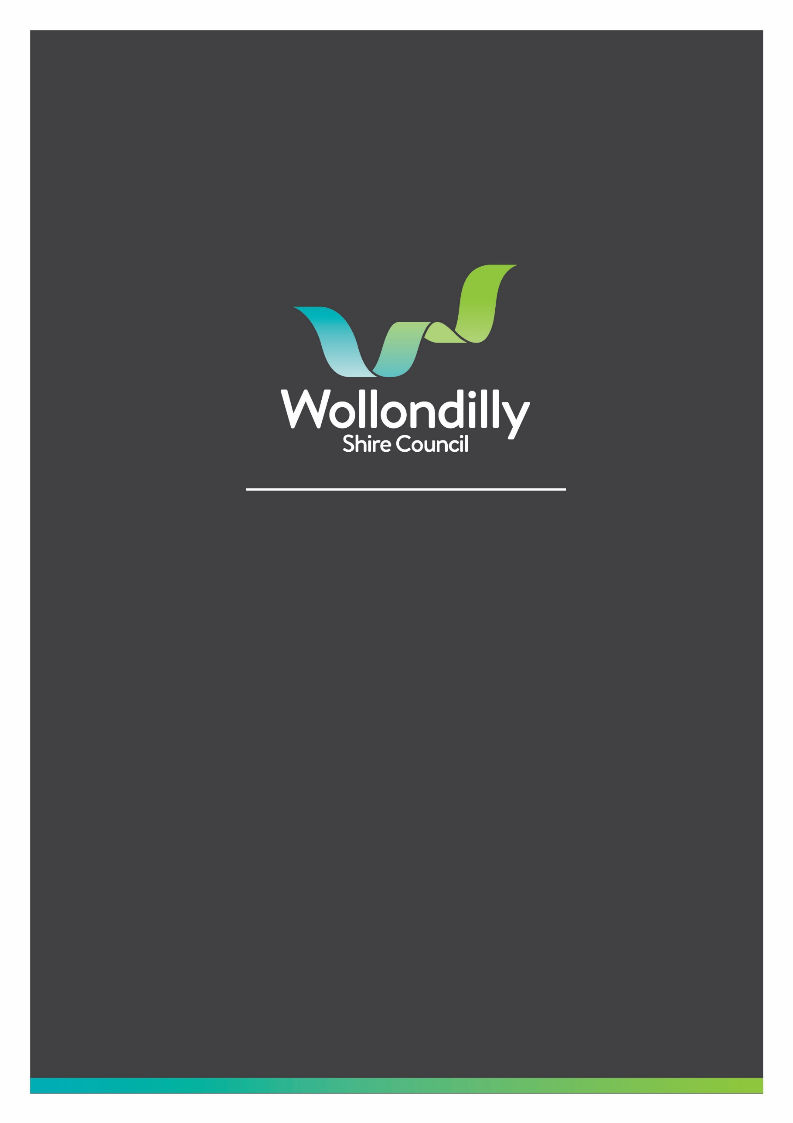

NOTICE OF COMMUNITY FORUM

TUESDAY 19 MARCH 2024

You are invited to attend the next Community Forum to be held in the Council Chambers,
Wollondilly Shire Hall 52 Menangle Street Picton and remotely via audio visual link on Tuesday 19 March 2024 commencing at 6.30pm. The link to access the meeting and ticketing information will be made available on the Community Forum page of Council’s website.

https://www.wollondilly.nsw.gov.au/council/meetings/community-forums/

Contents
FORMAL COMMUNITY FORUM MATTERS 3
1. TITLE 3
COMMUNITY QUESTION/STATEMENT TIME 4
INFORMAL QUESTION/STATEMENT TIME 6
CONCLUSION AND INFORMAL DISCUSSIONS 7
YOUR COUNCILLORS 8
COMMUNITY FORUM DATES 9

FORMAL COMMUNITY FORUM MATTERS
There are no Formal Community Forum Matters.

COMMUNITY QUESTION/STATEMENT TIME
Community Question/Statement Time will be for those matters that relate to the Ordinary Meeting of Council Agenda.
Matters can be submitted to Council up until 12 noon on the day before the Forum.
The Chairperson will read out the matter and a Council representative may act as speaker and read out the question/statement submitted. Each speaker’s time will be determined by Council’s Code of Meeting Practice. There can be two (2) submissions for and two (2) submissions against each issue, with each speaker allowed a maximum of 5 minutes.
All matters will be addressed and a direct answer provided thereby completing the matter or, a response as to how the matter will be dealt with.
In accordance with Council’s adopted Community Forum Guidelines the Record of Proceedings will only record the name of the person raising the Question/Statement, whom they are representing and the matter/item for each written question/statement submitted for the night. Any additional documentation handed in on the night will be noted in the Record of Proceedings. No verbal comments will be documented

Agenda for Ordinary Meeting of Council – 26 March 2024
1 Opening …………………………………………………………………………………………………………………….8
2 Recording of the Meeting …………………………………………………………………………………………..8
3 Webcast Notice ……………………………………………………………………………………………………….8
4 National Anthem ……………………………………………………………………………………………………….8
5 Acknowledgment of Country …………………………………………………………………………………………..8
6 Apologies and Leave of Absence Requests ………………………………………………………………….8
7 Declaration of Interests ……………………………………………………………………………………………………….8
8 Confirmation of Minutes …………………………………………………………………………………………..8
9 Items to be Tabled ……………………………………………………………………………………………………….9
10 Mayoral Minute ……………………………………………………………………………………………………….9
11 Items by Exception ……………………………………………………………………………………………………….9
12 People ……………………………………………………………………………………………………………………………….10
12.1 Training Policy 10
12.2 Revision of Temporary Food Policy 12
13 Environment …………………………………………………………………………………………………………………..15
14 Place and Landscape ……………………………………………………………………………………………………..16
14.1 Maintenance of Sports Facilities 16
14.2 South Wilton Precinct Site Plan Proposals 23
14.3 Extension and reappointment of Wollondilly Shire Local Planning Panel Members 33
14.4 Exhibition of Draft Appin Growth Area Contributions Plan 36
14.5 Public Exhitibition of Strategic Asset Management Policy 45
14.6 Proposed Road Closure Abbotsford Road Picton 47
15 Economy …………………………………………………………………………………………………………………..49
15.1 Review of Farmland Rating Policy 49
16 Performance …………………………………………………………………………………………………………………..52
16.1 Adoption of Wollondilly Shire Council Property Strategy 52
16.2 New Signage for Wollondilly 55
16.3 Investment of Funds 29 February 2024 61
16.4 Public Exhibition of the Code of Meeting Practice 66
17 Notice of Motion/Rescission …………………………………………………………………………………………68
17.1 Notice of Motion - Completion of Hannaford Oval Masterplan 68
17.2 Notice of Motion - Footpath assessment results and improvements 69
17.3 Notice of Motion Control of Non-custodial cats 70
17.4 Notice of Motion - Responsible Cat Ownership 71
17.5 Notice of Motion - Tahmoor Park 72
17.6 Notice of Motion - Extension of the Mary Walker swimming season 74
18 Closed Reports …………………………………………………………………………………………………………………..75
18.1 Tender Recommendations - Government Services Building 76
18.2 Quarterly Legal Status 76
19 Questions with Notice ……………………………………………………………………………………………………..77
19.1 Tahmoor Unpleasant Odour 77
20 Closure of Meeting …………………………………………………………………………………………………78

INFORMAL QUESTION/STATEMENT TIME
Informal Question/Statement Time will be for any general issues as well as those matters that were not answered during the Formal Community Forum section.
Matters are required to be submitted prior to 12 noon on the day before the Forum.
The Chairperson will read out the matter and a Council representative may act as speaker and read out the question/statement submitted. Each speaker’s time will be determined in line with the Community Forum Guidelines. With each speaker allowed a maximum of 5 minutes.
All matters will be addressed and the person will either be provided with a direct answer thereby completing the matter or, a response as to how the matter will be dealt with.
In accordance with Council’s adopted Community Forum Guidelines the Record of Proceedings will only record the name of the person raising the Question/Statement, whom they are representing and the matter/item for each written question/statement submitted for the night. Any additional documentation handed in on the night will be noted in the Record of Proceedings. No verbal comments from the speaker will be documented.

CONCLUSION AND INFORMAL DISCUSSIONS
CONCLUSION
This section of the Forum will allow the Chairperson to provide a summary of the matters discussed and advise that the next Community Forum will be held on Tuesday 16 April 2024.

INFORMAL DISCUSSIONS
This section of the Forum will allow time for our community to speak openly with Councillors and Council Officers about any matter they wish to raise.

YOUR COUNCILLORS
MAYOR
Cr M (Matt) Gould Mobile: 0427 936 471
Email: matthew.gould@wollondilly.nsw.gov.au

EAST WARD
Cr M (Michael) Banasik Mobile: 0425 798 068
Email: michael.banasik@wollondilly.nsw.gov.au

Cr S (Suzy) Brandstater Mobile: 0407 801 242
Email: suzy.brandstater@wollondilly.nsw.gov.au

Cr M (Matthew) Deeth Mobile: 0428 335 743
Deputy Mayor Email: matthew.deeth@wollondilly.nsw.gov.au

Cr P (Paul) Rogers Mobile: 0407 825 774
Email: paul.rogers@wollondilly.nsw.gov.au

NORTH WARD
Cr B (Blair) Briggs Mobile: 0418 269 913
Email: blair.briggs@wollondilly.nsw.gov.au

Cr H (Hilton) Gibbs Mobile: 0407 872 138
Email: Hilton.gibbs@wollondilly.nsw.gov.au

Cr J (Judith) Hannan Mobile: 0414 557 799
Email: judith.hannan@wollondilly.nsw.gov.au

Cr B (Beverley) Spearpoint Mobile: 0407 822 251
Email: Beverley.spearpoint@wollondilly.nsw.gov.au

COMMUNITY FORUM DATES
Community Forums will generally be held on the third Tuesday of each month and will commence at 6pm in the Council Chambers, Wollondilly Shire Hall 52 Menangle Street, Picton.
Dates for the Community Forums for 2024 are as follows:
- Tuesday 16 April 2024
- Tuesday 21 May 2024
- Tuesday 18 June 2024
- Tuesday 16 July 2024
- Tuesday 6 August 2024
- Tuesday 22 October 2024
- Tuesday 19 November 2024
- Tuesday 3 December 2024

