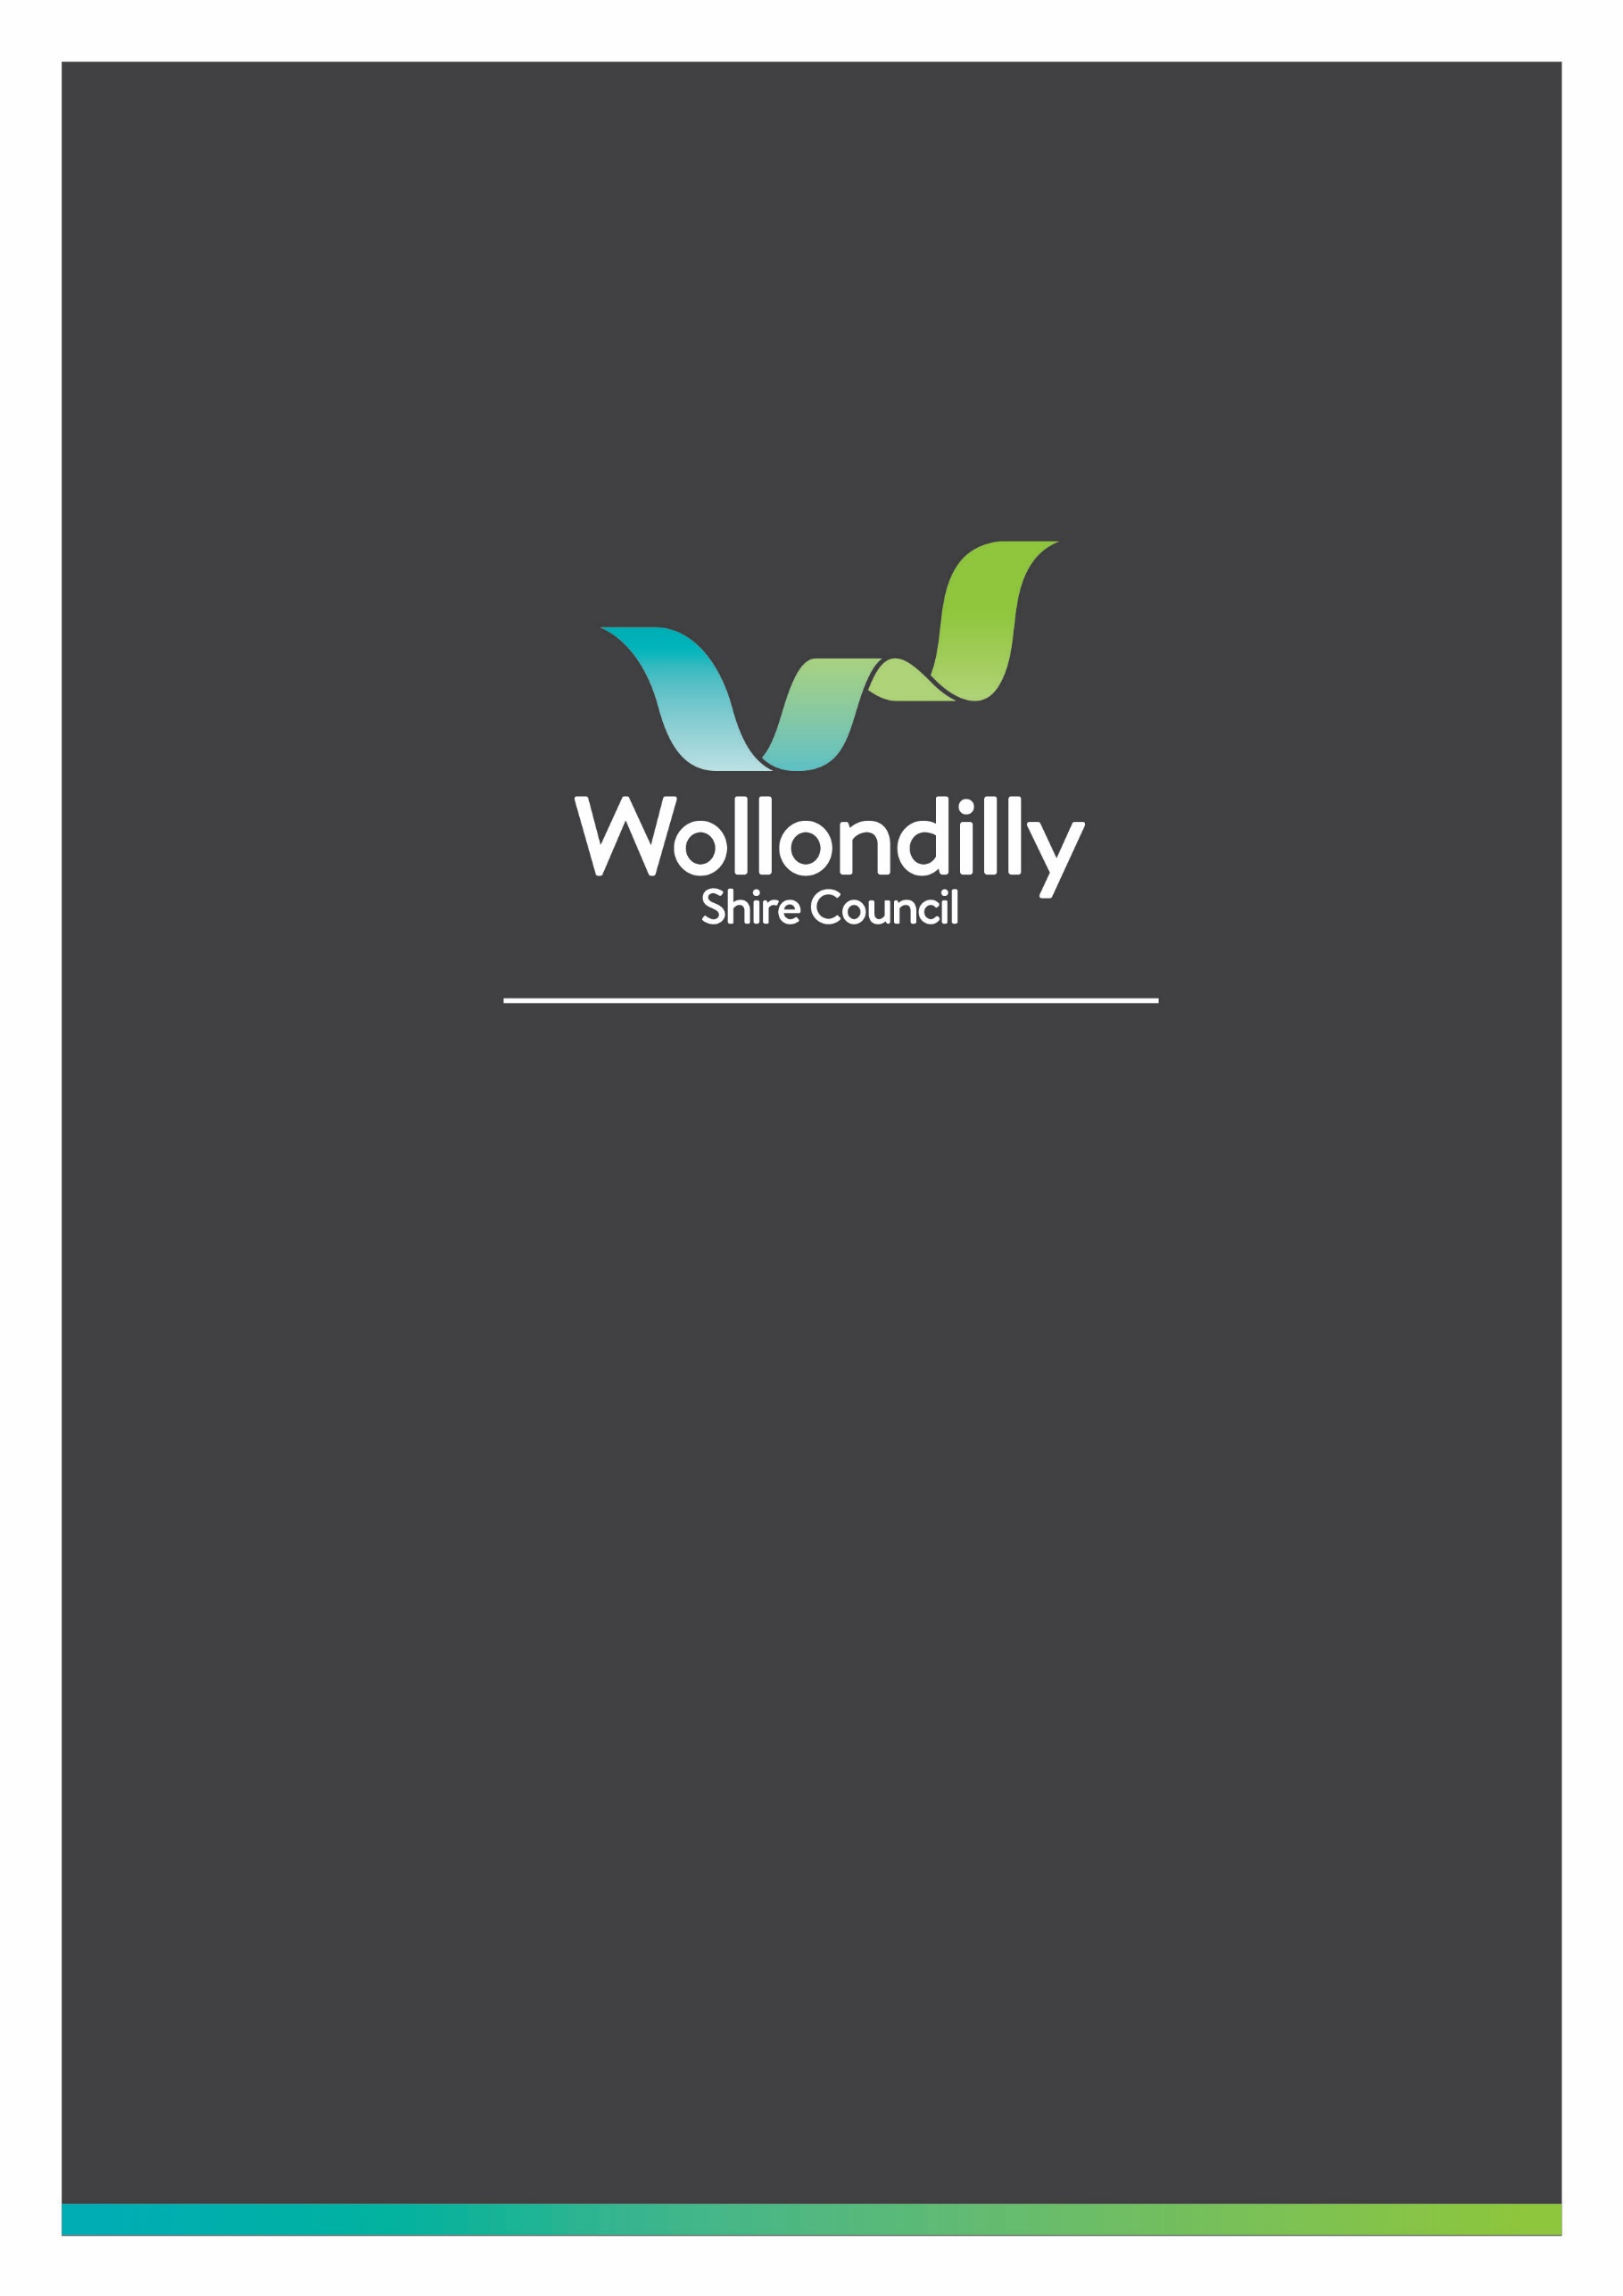

Community Group
Bus Hire Reimbursement Form 2022
CM: 996-4#29

PLEASE NOTE:

If your Community Group requires assistance with deposits, booking fees or arranging payments please contact Council’s Community Projects Team on
(02) 4677 1100

<INSERT SUB TEXT>

INFORMATION ABOUT THE REIMBURSEMENT SCHEME

Council is currently undertaking a review of its Community Bus Model of Service. As an interim measure Council will be providing Wollondilly based community groups, reimbursement up to the value of $500 (inclusive of GST) per day to cover the cost of bus hire. Council will reimburse community groups that use an identified not for profit community transport provider. Suggestions of suitable providers are listed at the bottom of this form. It is the community group’s responsibility to contact, hire and pay for the bus hire following which a request for reimbursement may be submitted.
The completed form should be submitted after each trip for reimbursement. Council will only be able to process the reimbursement after the submission of a completed form, which must include a paid tax invoice. This invoice must include the hiring business name and ABN of the provider. Any costs over $500 will need to be absorbed by the community group and will not covered by Councils Community Bus Hire Reimbursement Scheme.

Completed forms to be emailed to council@wollondilly.nsw.gov.au

COMMUNITY GROUP DETAILS

Community Group Name:
Contact Person:
Contact Email:
Contact Number:
Postal Address:
Number of Passengers:

EXPENSE

Date of trip | Detailed description of expense  Include outing destination/purpose | Name of community transport provider | Cost
 |  | Total

COMMUNITY GROUP BANK ACCOUNT DETAILS

Payment Type: | ELECTRONIC BANK TRANSFER
BSB:
Account Number:
Account Name
Bank Name:

CERTIFICATION

I hereby certify that the infromation contained in this form is true and correct
Name:
Signature:
Date:

COMMUNITY TRANSPORT OPERATORS
South West Community Transport | 02 9426 8999
Nepean Food Services | 02 4733 7200
IC Care  Wollondilly Home & Community Care | 02 4677 2524
Firebird Support Services | 0493 286 543

OFFICE USE ONLY
Date received:
GL Number:
Responsible Officer:
Date referred to finance:

PASSENGER DETAILS

Please provide a list of passenger names and contact details. This information will help inform our review of the Community Bus Model of Service and will be kept confidential. If you would like to have your activity promoted through Council’s communications channels, please provide a high-resolution photograph along with a short paragraph describing your event.
Promotion will be subject to marketing deadlines.
Passenger Name | Suburb | Email | Phone Number

Completed forms to be emailed to council@wollondilly.nsw.gov.au

