INFORMATION PACKAGE

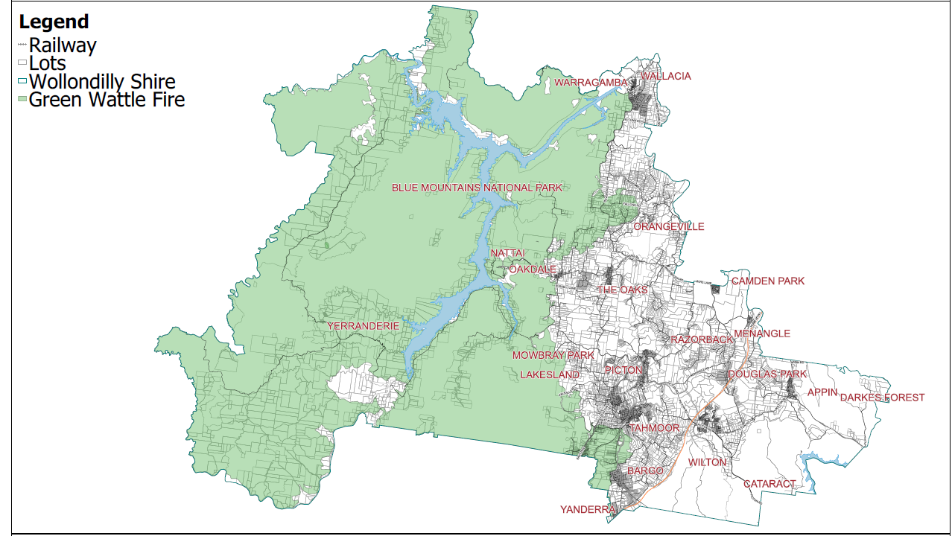
The green area above indicates the Green Wattle Creek Fire burn scar (burnt area).
The residential property must be within this burn scar to be eligible for funding assistance.

Stage 1
Eligibility Criteria:
- The residential property must be within the Wollondilly Shire.
- Submissions can only be made by the land owner.
- Only one application per resident/residential address will be considered for funding. This grant is not available to residents who have already undertaken works as part of this grant.
- Property was directly impacted by the 2019/20 Green Wattle Creek Bush Fire. This will be confirmed by Wollondilly Shire Council staff using the Geographic Information System (GIS) Burn Scar Map.

If your property meets the above criteria, you may submit the attached Expression of Interest Form.

Expressions of Interest will be assessed and awarded on a first registration basis, with successful applicants being advised in writing within 14 days.

Expression of Interest applications close on 30 March 2023.

Stage 2

Successful Expressions of Interest:

Successful Expressions of Interest will be confirmed by Council Staff in writing, granting permission for the resident to obtain a Level 5 Arborist Report. The cost of this report will be covered by the grant program. There will be no out-of-pocket expenses to the resident for the report.
The report must meet the following requirements:
- The trees must be assessed and a written report on business letter head provided.
- The assessment must be provided by a Qualified Level 5 Arborist.
- The report should confirm the number of trees deemed dangerous and/or posing a threat to property and/or human life. Photos of the trees discussed should also be included.
- The Arborist assessing the trees must comply with Council’s Tree Management Policy and provide a written assessment with recommendations for removal or lopping.

The resident is to submit the invoice for the cost of the report, along with the completed report, addressed to Wollondilly Shire Council, to recovery@wollondilly.nsw.gov.au. The cost of this report will be covered by the grant program. There will be no out-of-pocket expenses to the resident for this report.

Please note that the cost of the report is included in the maximum $10,000 funding that each property owner may be eligible for.

Once submitted, the Arborist Report will be assessed by Wollondilly Shire Council’s Tree Management Team. Please note, the submitting of a Level 5 Arborist Report does not guarantee that the works will be approved by Council.

If the Tree Management Team are required to undertake a site inspection, residents will be notified at this stage.

Residents will be notified of the outcome of the assessment in writing by Council’s Community Recovery Officer.

Stage 3

Level 5 Arborist Report confirms eligibility:

If the Level 5 Arborist Report confirms eligibility, the property owner will then be asked to submit two (2) written quotes on business letterhead. These quotes need to be provided by a Qualified Level 3 Arborist. Website downloads will not be accepted.

The two quotes, along with the property owner’s preferred service supplier, should then be sent to Council’s Community Recovery Officer at recovery@wollondilly.nsw.gov.au.

Each eligible resident is able to access funding up to $10,000. This includes the cost of the Level 5 Arborist Report. If the cost of the approved tree works and the report are above $10,000, the resident would be required to review the Scope of Works or cover the cost of any gap fee.

Once the quote is approved:
- Written permission to proceed with the approved tree works will be sent to the resident and the service provider/arborist, along with the approval conditions and a Purchase Order Number.
- Supplier invoice to be submitted to Wollondilly Shire Council within two weeks of completion.
Invoice should be addressed to Wollondilly Shire Council.
- Funding will be provided by EFT (Electronic Funds Transfer). Payment of tax invoices to an approved supplier and will not be paid in cash or kind to the applicant/resident or supplier.
- Photo evidence of before and after works will be required and is the responsibility of the property owner.

If a Council property inspection is required, Council will notify the resident after the Level 5 Arborist Report has been reviewed. Please inform us if you have access issues such as dogs or locked gates requiring a code.

Unfortunately, Council is working to a short time frame to inspect and work with contractors to undertake these works. We appreciate your prompt response on this matter.

Further information

For further information on Council’s Tree Management and Environmental Vegetation Policy, please visit:
https://www.wollondilly.nsw.gov.au/environment-biodiversity-and-sustainability/tree-management/trees-private-property/.

To register your interest in this Community Grant Program, please complete the following:
- Expression of Interest & Consent to Enter Property Form - closes on 30 March 2023.

If the Expression of Interest application is successful, you will progress to stages 2 and 3 as outlined above.

To assist you in the process, we have provided the following local tree companies that have the appropriate qualifications, experience and equipment to assist residents with these works.
However, Council is not indicating that these are the only contractors you can engage.

- CPE Tree Services – 4654 5100
- Friendly Fred’s Tree Service – 4655 1133
- Quality Tree Service - 1300 131 787

Please return the attached form by 30 March 2023 via email to recovery@wollondilly.nsw.gov.au.
You may also post or deliver the form, if preferred.

Should you require any further information or have any questions, please call 4677 9757

or email recovery@wollondilly.nsw.gov.au.

T  A  E  W | (02) 4677 9757  PO Box 21, Picton NSW 2571  recovery@wollondilly.nsw.gov.au  http://www.wollondilly.nsw.gov.au

